Guided Exploration M03: Loops, Methods and Testing

Points: 25 (See Rubric in Canvas)
Due Date: Due date listed in Canvas but some sections will be due as class participation before. Create Calendar reminders
- Final submission will be accepted up to 24 hours after the due date with a 10% penalty. Meaning if you turn it in at 12:01 am of the next day you will be deducted 10% of the total points from your score.
- If the assignment is more than 24 hours late, it will be a 0.
Submission: Upload files separately and do not upload a zip file.
- Two Document Files as PDF or Word document: This document with your answers in the highlighted areas unless otherwise stated and Technical Document
- One Java Files (. java files NOT CLASS FILES): Code from
  - 2.2 Practice Software Development Life Cycle

Objectives: See objectives in canvas

Effort: You are encouraged to collaborate to discuss concepts and explore writing code together. Remember
- Review lectures and links in the lectures to information first.
- Follow CS Academic Integrity and AI Policy - Harding
- If you find you don’t understand the information in the lecture reach out to Deb, Elaine or Heriberto
Part 1: Explore and Explain
Part 2: Apply
2.1 Practice Writing code
2.2 Practice Software Development Life Cycle
Task 1: Display summary of program including
Task 2: The professor will enter the final percentage grade for each category.
Task 3: Calculate final grade percentage
Task 4: Determine Final Letter Grade
Task 5: Repeat Calculating Grade
Optional Task challenge if you have experience.

Part 1: Explore and Explain
Open your tech document.
- Add a new Title for GE03 and subtitle for the different lectures
- Go back to the lectures and the code I had you explore in class.
- Practice writing code and include comments.
- Summarize the concepts and copy and paste your example code into your tech document.

Objectives:
- Understand and Explain Loops and Nested Control Structures
  - different types of loops: for, while, do-while
    - When to use the different loops
    - different ways to exit a while loop
    - ways you should not use to exit a loop
    - Sentinel values and boolean flags
  - Scope of variables in loops
  - Nested loops and conditions
- Understand and Explain Methods
  - Method signature: Method Name, Parameters and Return Value
  - Write and call your own methods you define.
- With and without parameters
- With and without return value
      - Each method should only have one return value at the end of the method
  - Scope of variables in methods
  - Stack Frame Memory when calling methods and Pass by Value

Part 2: Apply
Implement Control Structures and Methods to Write solutions in Java
  - Implement loops and conditions and nested control structures to control the flow of a program
  - Implement methods to modularize repetitive code and follow single responsibility principle and do not repeat your self

2.1 Practice Test Cases, Design, Writing code and Test
Remember to commit and push.
1. Write test cases to find the sum of the numbers 1 to a max. For example if max is 4 then the sum is 10 because 1+2+3 + 4 = 10
I included one for you. Finish the coding note for my example. Then add two more test cases and notes

Precondition | Postcondition | Coding Notes
max = 4 | sum = 10 | sum is initialized to 0  A loop should go from 1 to 5  First time in loop sum = sum + 1  FILL IN THE NEXT STEP OF LOOP  Second time in loop sum += 2  Third time in loop sum += 3  Fourth time in loop sum += 4  Sum = 10
Max = 1 | Sum = 1 | Sum is initialized to 0  A loop should go from 1 to 1  First time in loop sum = sum + 1  Sum = 1
Max = 2 | Sum = 3 | Sum is initialized to 0  A loop should go from 1 to 2  First time in loop sum = sum + 1  Second time in loop sum += 2  Sum = 3
Max = 3 | Sum = 6 | Sum is initialized to 0  A loop should go from 1 to 3  First time in loop sum = sum + 1  Second time in loop sum += 2  Thir time in loop sum += 3  Sum = 6

2. Design your algorithm to solve the problem.

What loop do you think you should use?
A traditional if loop since we know how many iterations we need based on max
Write the pseudocode on paper you think will work.
Take a picture and put the picture below.
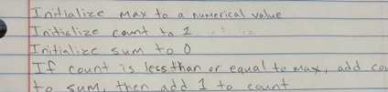
3. Write the code in Eclipse and test it. Use the debugger to see what the code is doing.

Paste your code below.

public static void main(String[] args) {
int max = 4;
int sum = 0;
for (int count = 0; count <= max; count++) {
sum += count;
}
System.out.println(sum);
}
4. Create a method to sum the number 1 to max. You will pass the max to the method and return the sum.

4.1 Write the method signature - what is returned, name of method and the parameters for the method.

public static int getSumFromOneToMax(int maxNumber)

4.1 Write the code for the method in Eclipse.
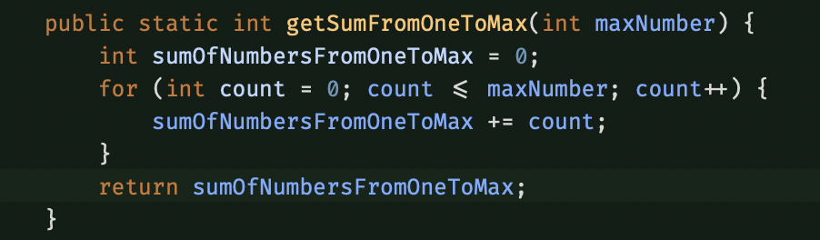
4.3 Call the method from main and store the sum that is returned
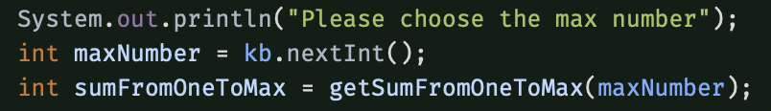
4.4 In main print the max and the sum.

5. On paper, draw methods stacks and explain how the max is passed from the main method to the sum method. Take a picture of your drawing and put it below.

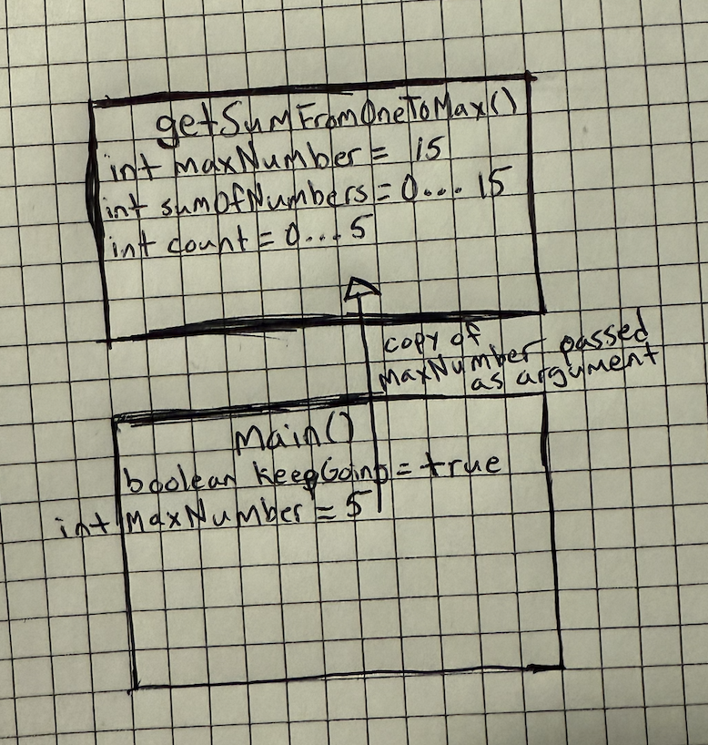
6. Update your technical document with what you learned. No need to turn in your java file.

2.2 Practice Software Development Life Cycle
Make updates to your code using these examples.

This is to help you practice but it is ok if you don’t get everything working. You should have code showing you tried to implement all the methods.

User Story:
Professors need a program to calculate a student’s final grade when entering the final grade for each category and display percentage and grade so they do not need to do the calculation.

You are adding more features to your code from GE M01 and GE M03. Here are the tasks to help you solve the problem.

Follow Software Development Life Cycle for each task
- Break into smaller tasks where each has a single responsibility to help write your methods
- Use Test Driven Development to
  - Create preconditions and postconditions and algorithm notes
  - Write algorithm in pseudocode on paper
- Determine method signature - name, parameters and return values
- Create the method and call from main, debug and test that it works.
- Commit and push

Task 1: Display summary of program including
- Grading categories and weights
- Grading Scale

Output example
**********************************
CS1050 Final Grade Calculator
**********************************
------------------------------
Category:Percent
------------------------------
Class Participation: 10%
Guided Exploration: 20%
Module Quizzes: 25%
Project Iterations: 25%
Final Exam: 20%
-------------------------------
Letter Grade Range
-------------------------------
A: 90 to 100
B: 80 to < 90
C: 70 to < 80
D: 60 to < 70
F: < 60

No need for test cases or algorithm

Determine method signature - name, parameters and return values
- Does the method need any information
no
  - What does the method signature look like if there are no parameters?
public static void programStartUpMessage()
- Does the method return any information
no
  - What does the method signature look like if there are no return values?
public static void programStartUpMessage()
Create the method and call the method from main.
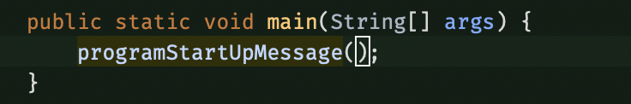
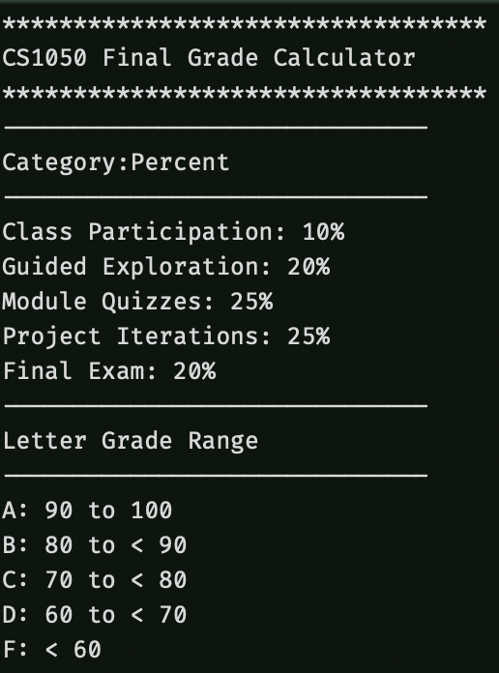

Task 2: The professor will enter the final percentage grade for each category.
- When grade not 0 to 105 display error and repeat until valid grade entered

Output and input example
Enter the Class Participation grade: 95.5
Enter the Guided Exploration grade: 88.4
Enter the Module Quizzes grade: 110
Enter a value from 0 to 105: 80.3
Enter the Project Iterations grade: -1
Enter a value from 0 to 105: 87.4
Enter the Final Exam grade: 92.3

Create 4 test cases and include edge cases such as, -.1, 0, 88.5, 105, 105.1

Precondition | Postcondition | Coding Notes
Grade entered = -1 | Invalid | Repeat question
0 | Valid | Move on to next line
88.5 | Valid | Move on to next line
105.2 | Invalid | Repeat question

Write the algorithm in pseudocode on paper.

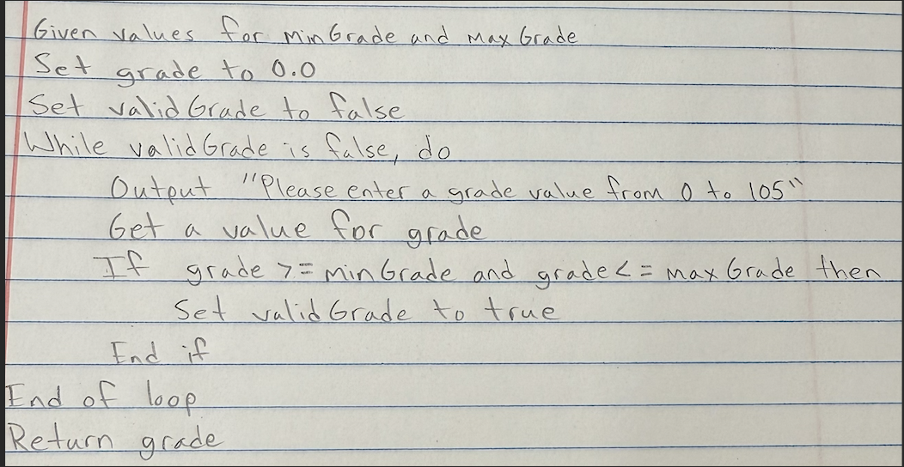
Think about what the method needs and what will be returned. For example, for this method the signature would be
- Name for the method: getValidGrade
- Parameters: the max and min values as integers
- Return the grade as a double
double getValidGrade (integer min, integer max )
/**
* Repeats prompting for double number until number with in range of min and max
* @param int min for valid grade range
* @param int max for valid grade range
* @return double valid grade value
*/
public static double getValidGrade(int min, int max)
{
double grade = 0.0;
boolean validGrade = false;
Scanner kb = new Scanner(System.in);
while (!validGrade) {
System.out.println("Please enter a grade value from 0.0 to 105.0: ");
grade = kb.nextDouble();
if (grade >= MIN_GRADE && grade <= MAX_GRADE) {
validGrade = true;
}
}
kb.close();
return grade;
}
In main you will ask the question and then call the method as follows:

final int MIN_GRADE = 0
final int MAX_GRADE = 105
System.out.print("Enter Class Participation grade: ");
double classParticipation = getValidGrade(MIN_GRADE, MAX_GRADE);
System.out.print("Enter Guided Exploration grade: ");
double guidedExploration = getValidGrade(MIN_GRADE, MAX_GRADE);

Continue asking for other grades. Using the method you wrote should guarantee that only valid grades have been entered so you can go to the next part to calculator the grades.
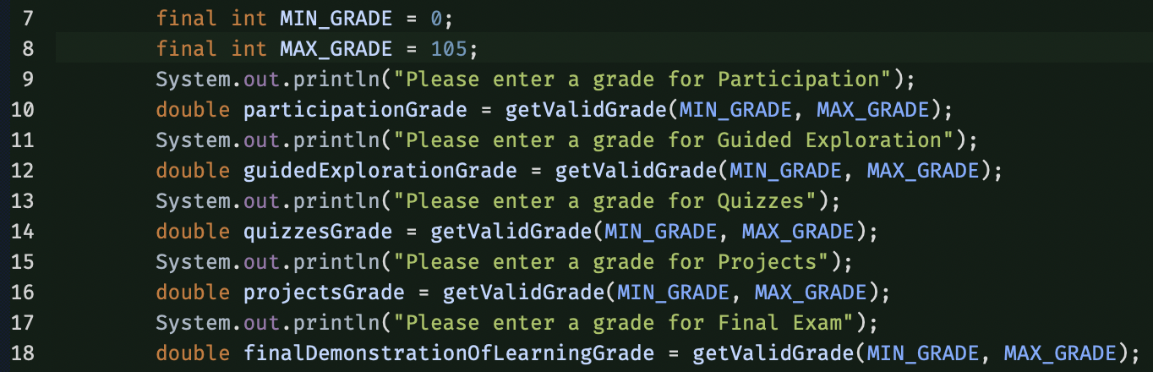

Task 3: Calculate final grade percentage
Output Example
Final Percentage: 88.02

No need for test cases as this should already have been correct from GE M01

Think about what the method needs and what will be returned.
- Name for the method: calculateGrade
- Parameters: each category grade
- Return: final grade

Method signature:
public static double calculateGrade(double participationGrade, double guidedExplorationGrade, double quizzesGrade, double projectsGrade, double finalExamGrade)

Create the method
Call the method from main
In main Print the final grade numeric value to two decimal places that is returned
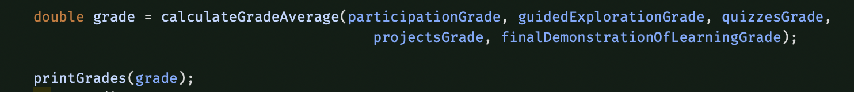

Task 4: Determine Final Letter Grade

A | 90 or greater
B | 80 or more but less than 90
C | 70 or more but less than 80
D | 60 or more but less than 70
F | Less than 60

No need for test cases as this should already have been done in GEM02

Think about what the method needs and what will be returned.
- Name for the method: getLetterGrade
- Parameters: double grade
- Return: char letterGrade

Method signature: public static char getLetterGrade(double grade)

Create the method
Call the method from main
Then in main Print the final latter grade that is returned

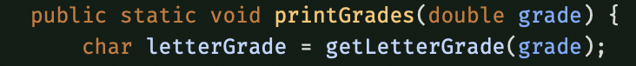

Task 5: Repeat Calculating Grade

Ask the user if they want to enter another student’s grade. If they enter ‘y’ as first character repeat for next student otherwise display “Exiting grade calculator” and end program

Program Output and Input Example when enter y means the task 2, 3, 4 and 5 will be repeated.
Do you want to calculate another student's grade?
Enter y for yes or n for no y

Program Output and Input Example when user enters any other character than y such as n or x will exit the loop.
Do you want to calculate another student's grade?
Enter y for yes or n for no n
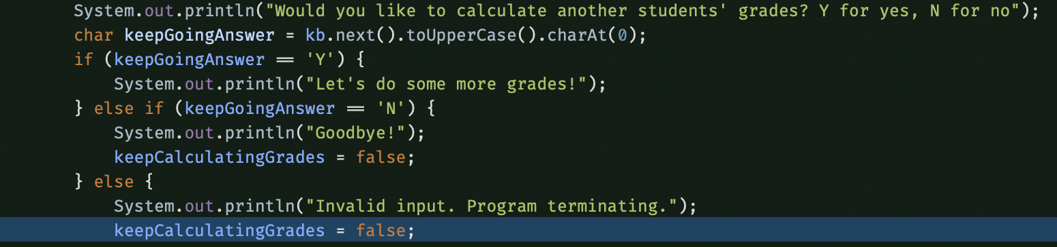

Create 3 test cases

Precondition | Postcondition | Coding Notes
keepGoingAnswer = ‘Y’ | keepCalculatingGrades = true; | keepCalculatingGrades initialized to true, so it doesn’t change here. Loop iterates again
keepGoingAnswer = ‘N’ | keepCalculatingGrades = false; | Meets else if condition, sets boolean to false and terminates loop
keepGoingAnswer = ‘W’ | keepCalculatingGrades = false; | Invalid answer, program sets boolean to false after printing message to user that input was invalid

Does the loop at least run one time? Do you know how many times the loop will run?
What type of loop would be best?
This loop runs at least once since I initialized the boolean to true; I could have used a do-while loop to achieve the same goal, but I am more comfortable with this methodology. I think a do-while would be most appropriate, though

What will be repeated?
Everything in the body of the while loop, which in my code is all of main except for the lines instantiating the scanner, initializing the boolean, opening message, and closing the scanner. The welcome message will be repeated first, and then the methods for gathering grades and averaging them out before printing the average, letter grade, and asking if we should repeat the loop yet again

How can you add this loop to the main method so the code you created above in main will only repeat tasks 2 to 4 above?

Surround all of main starting after the lines where you print the opening message, and ending just before you close the scanner

Optional Task challenge if you have experience.
Ask the instructor to log in before allowing them to enter grades.
- See Login Scenarios but add this one scenario
- After 3 attempts the user is locked out and the program ends
- The method returns a boolean value whether the successfully logged in
- If the logged in they enter grades
- If they didn’t log in the program ends

Read what the deliverables are for this assignment and submit them all to canvas. You can submit at different times but pay attention to the due date and the late date.

